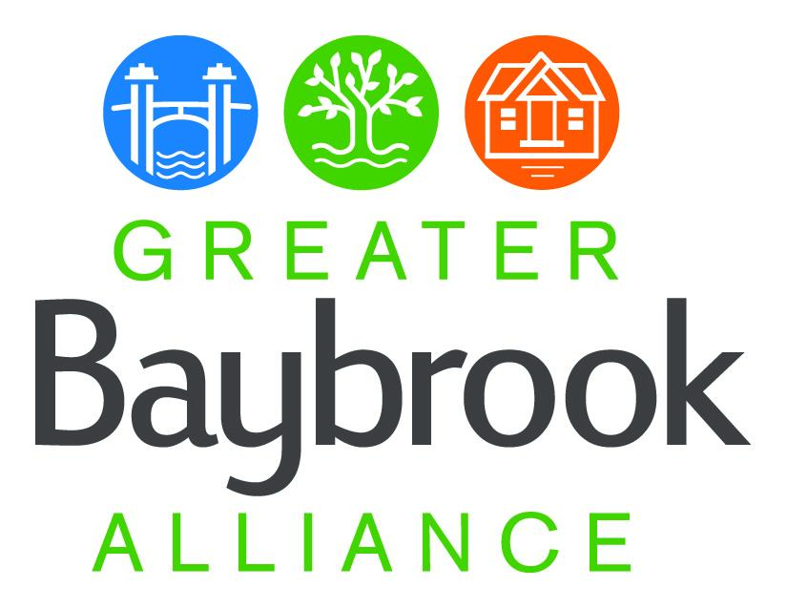

Greater Baybrook Alliance

Steering Committee agenda:

March 27, 2024, 6-7:30 pm

Chesapeake Arts Center, 3rd-floor conference room

194 Hammonds Ln, Brooklyn Park, MD 21225

6:00 Welcome and GBA Board update - Dan McGinty

Nominations for Board, nominations for Steering Committee Co-chairs

6:20 Maryland State Revitalization Programs (BRNI) pipeline of proposals for community review

6:40 Study of Community Perceptions of Behavioral Health Clinics - presentation by Justin Rose, PhD Candidate, Health and Public Policy; Johns Hopkins Bloomberg School of Public Health

7:05 Proposed redevelopment of Potee brownfield, Mitch Gold

7:15 Community updates

7:30 Adjourn