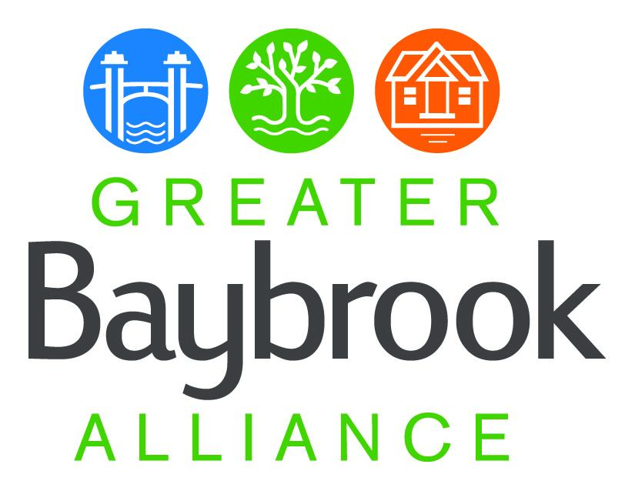

Greater Baybrook Alliance

Steering Committee agenda:

March 27, 2024, 6-7:30 pm

Chesapeake Arts Center, 3rd-floor conference room

194 Hammonds Ln, Brooklyn Park, MD 21225

6:00 Welcome and GBA Board update - Dan McGinty

Nominations for Board, nominations for Steering Committee Co-chairs

6:20 Maryland State Revitalization Programs update, Emma Simpson, Deputy Director

6:30 Behavioral Health Clinics - presentation by Erica Quan, Public Safety Fellow

7:10 Community news and announcements

7:30 Adjourn